**1) Configure VPC peering in cross regions.**

**Done this one in previous assigned task, and I have documents for it.**

**2) Purchase one domain from godaddy**.

Pruchase domain from godaddy, my domain name is **Techzoom.shop**

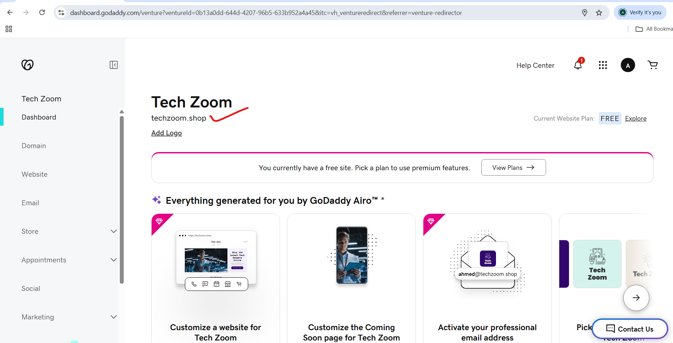

**3) Deploy static website in s3.**

Created s3 bucket for deploy static website:

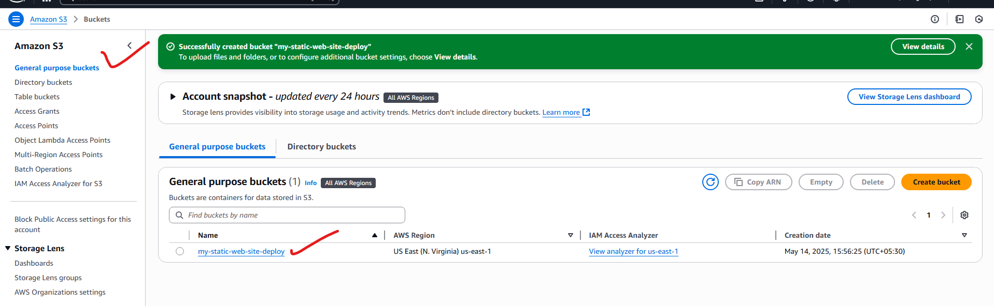

objects are uploaded in s3 bucket:

Index.html and error.html

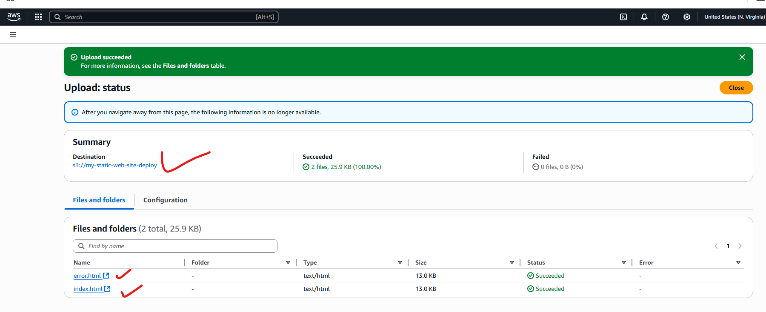

Enabling the static website hosting:

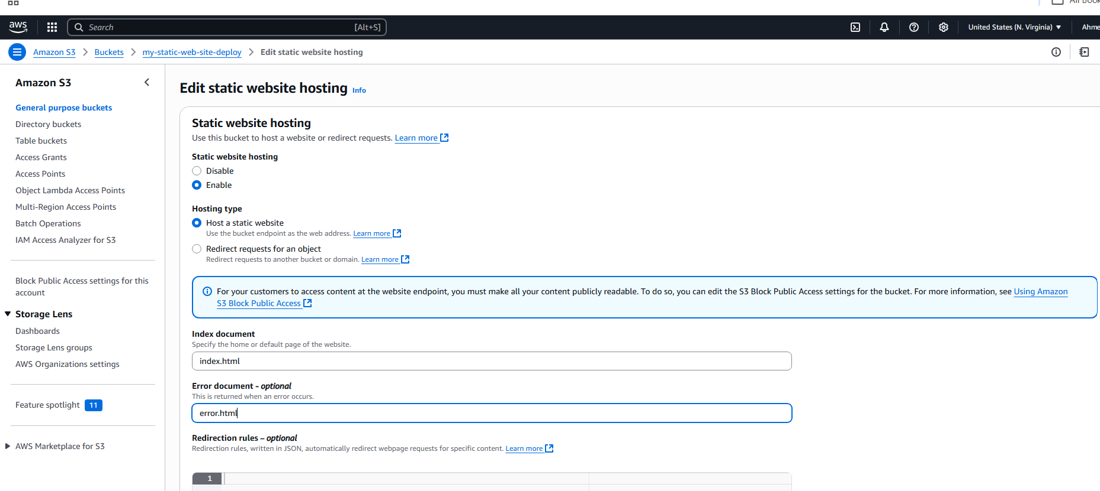

Make the objected public:

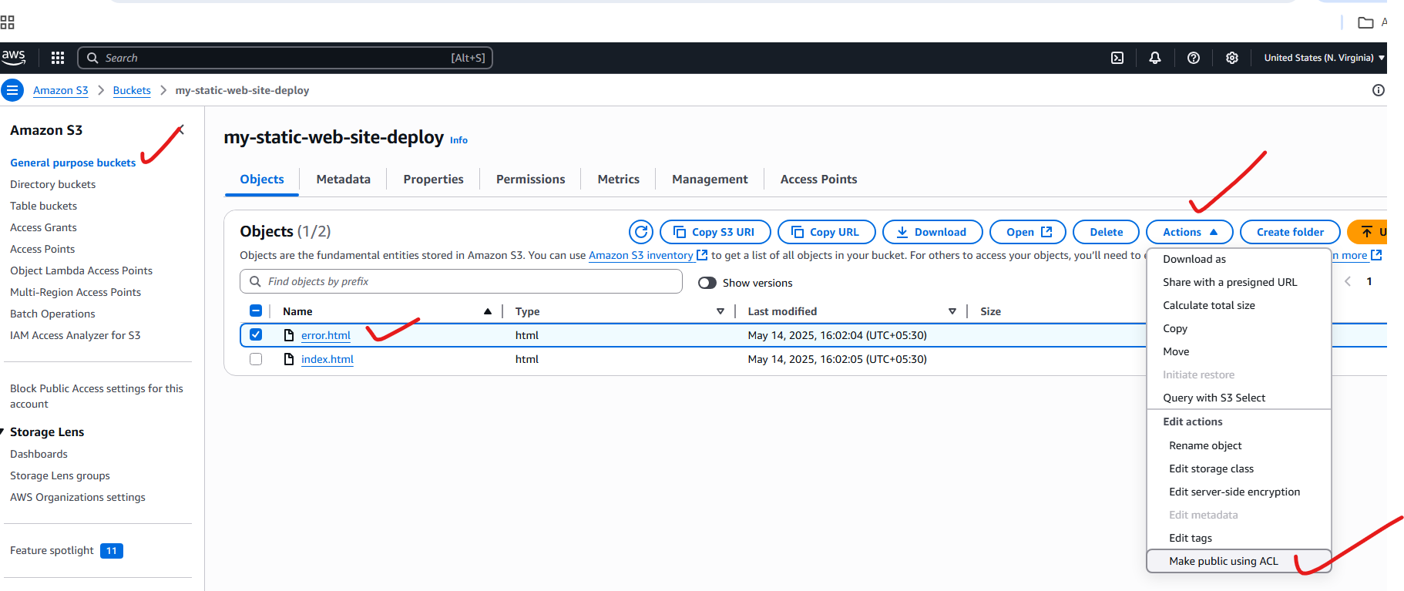

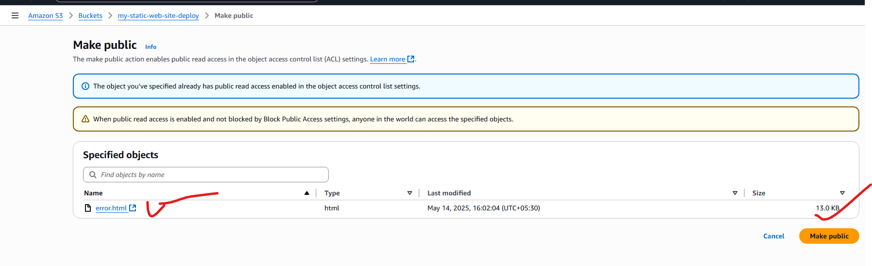

This the way we make it public:

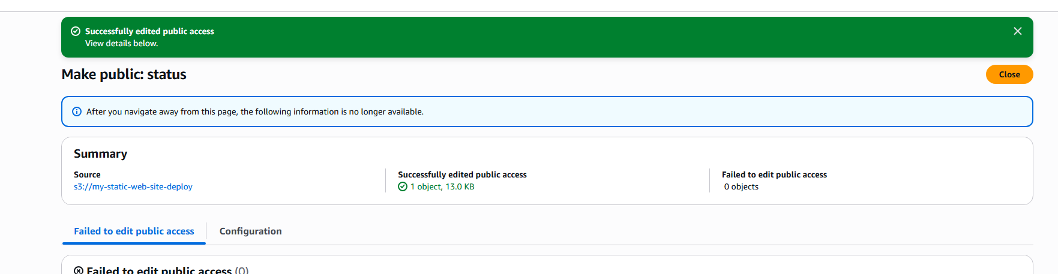

Copy the object link and paste in browser and check for testing, whether my static website is working as expected or not.

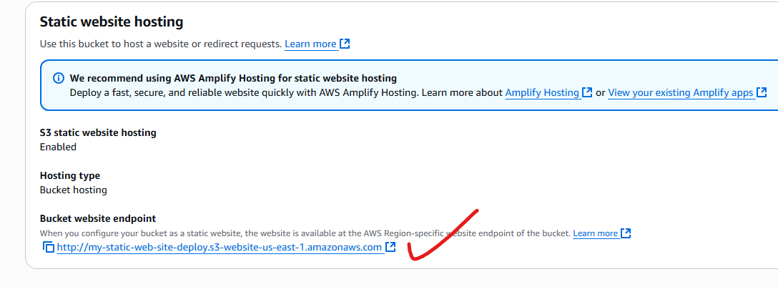

**Successfully uploaded the objects in static-website and browse it for accessing the objects.**

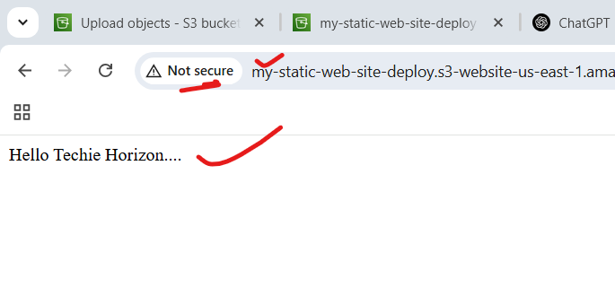

**This is our agenda:**

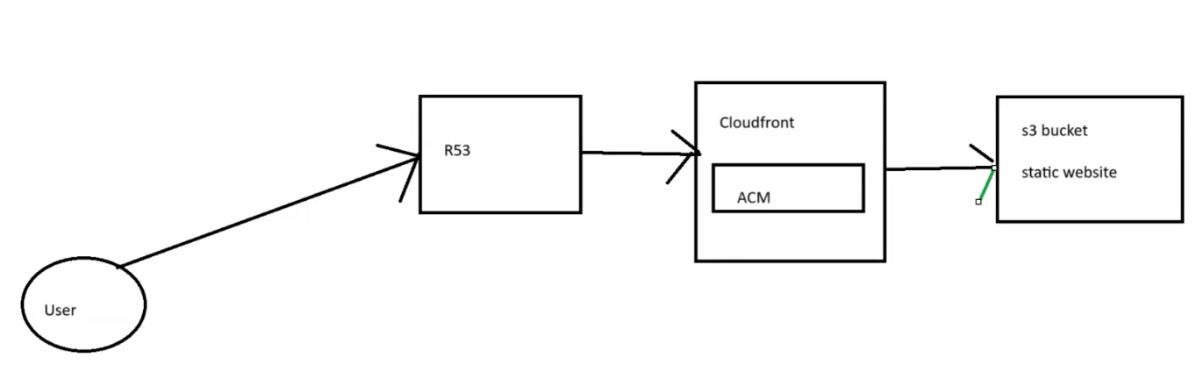

**4) Create CDN and attach one SSL certificate.**

Created CloudFront Distribution successfully:

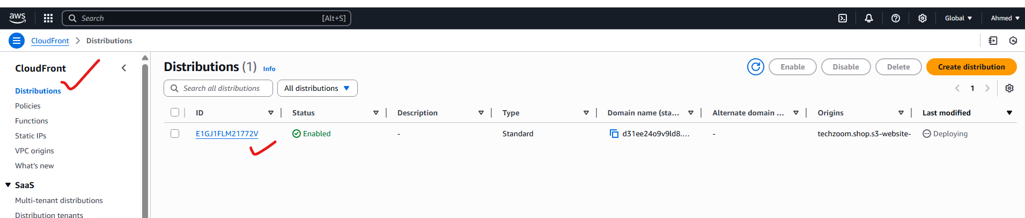

**We can access the s3 bucket object with cloud front distribution:**

**By distribution Domain name.**

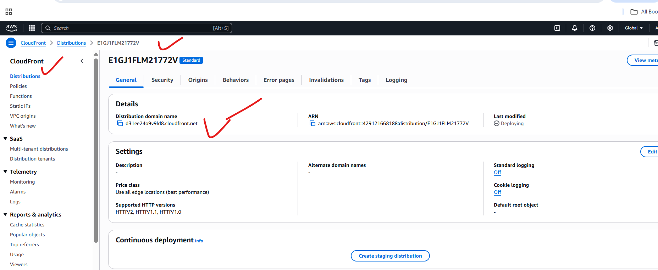

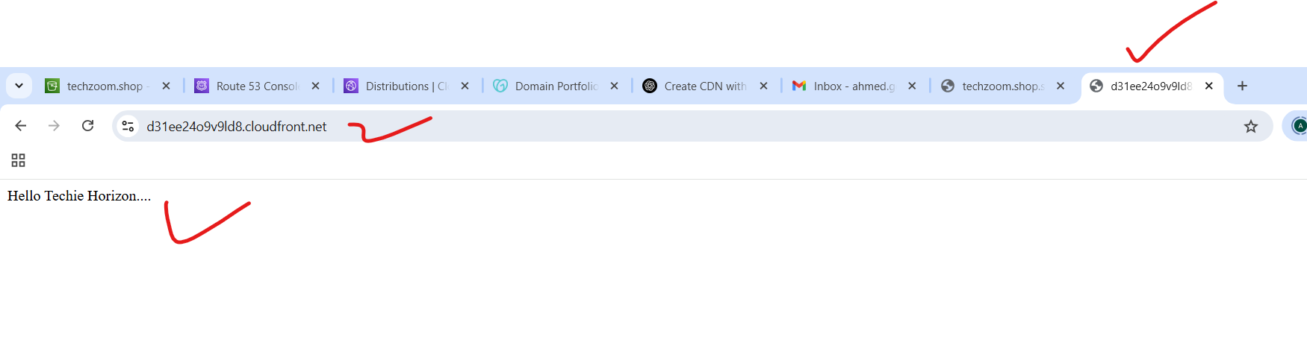

**5) Create Route53 hosted zone and MAP the domain with CDN.**

**Route53 hosted zone created:**

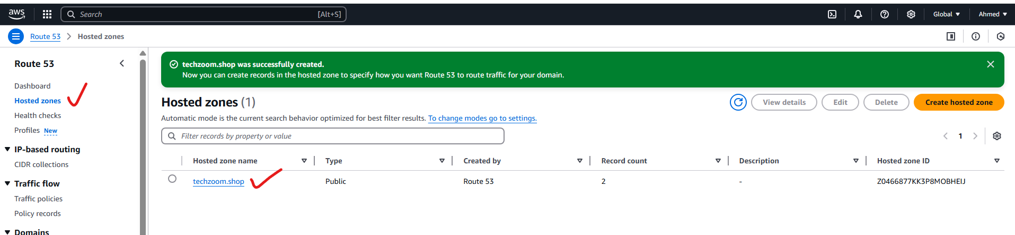

**Created s3 bucket with domain name:**

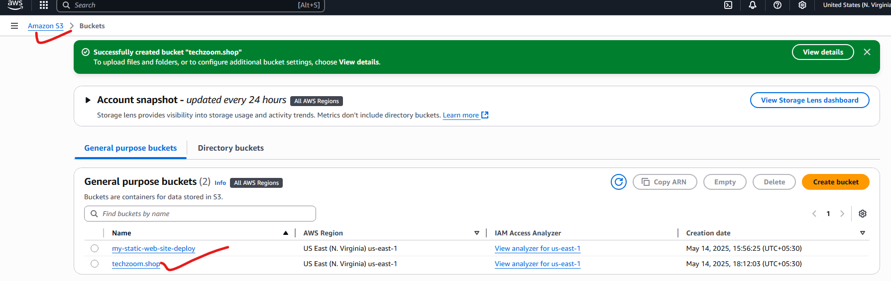

**Successfully deployed our static website In s3, and accessing through web browser:**

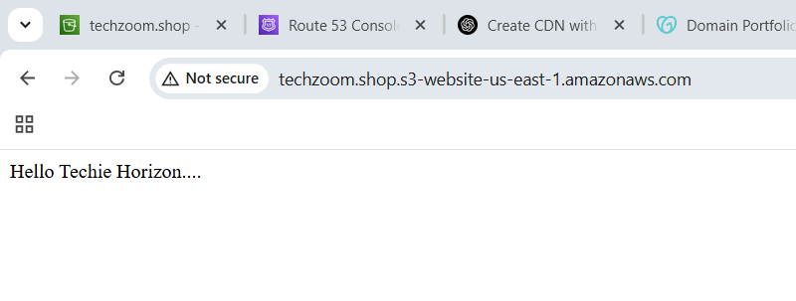**Now I am connecting our Route53 with CloudFront**

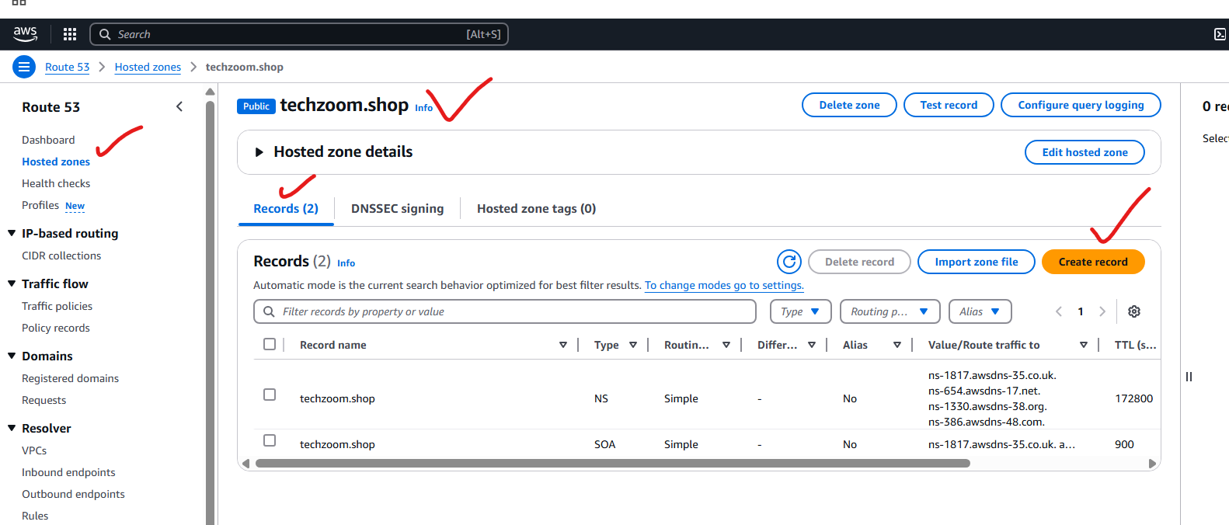

**Before establishing the connection from Route53 to CloudFront, we need to do this: SSL certificate.**

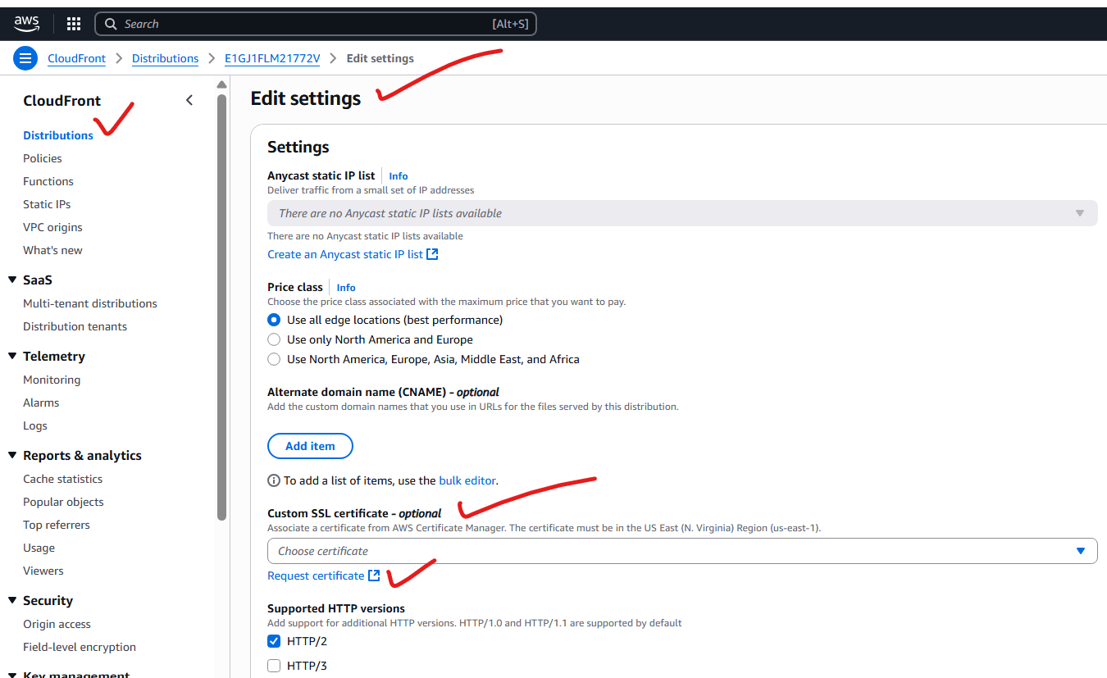

**This service help us to get SSL certificate.**

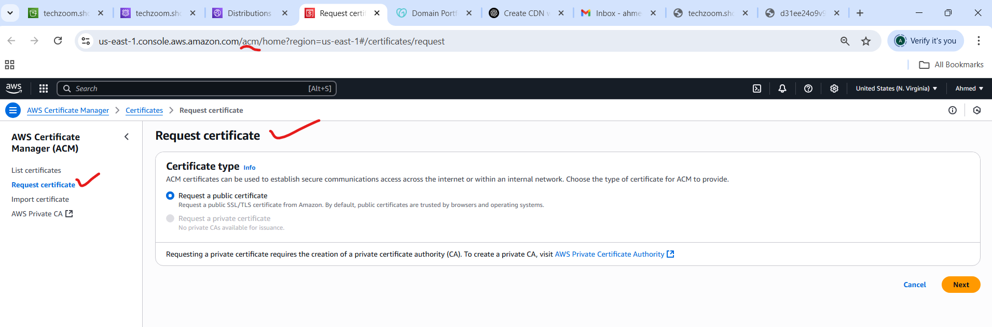

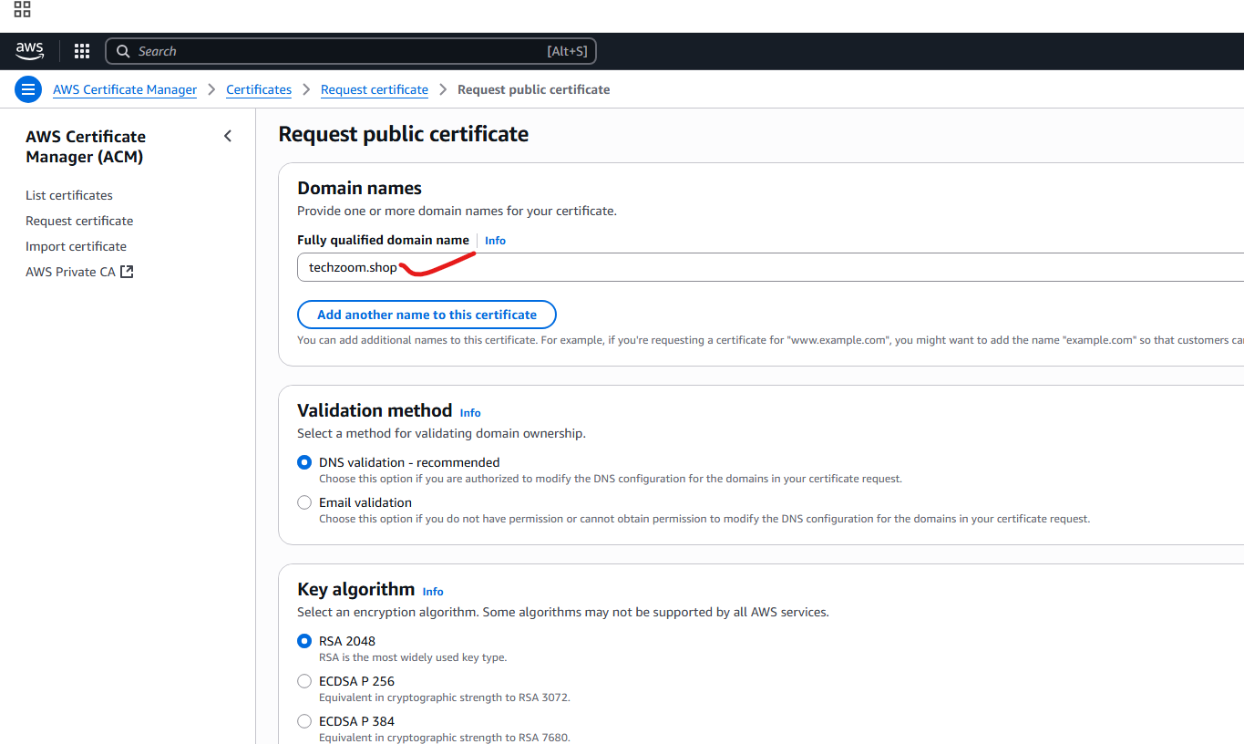

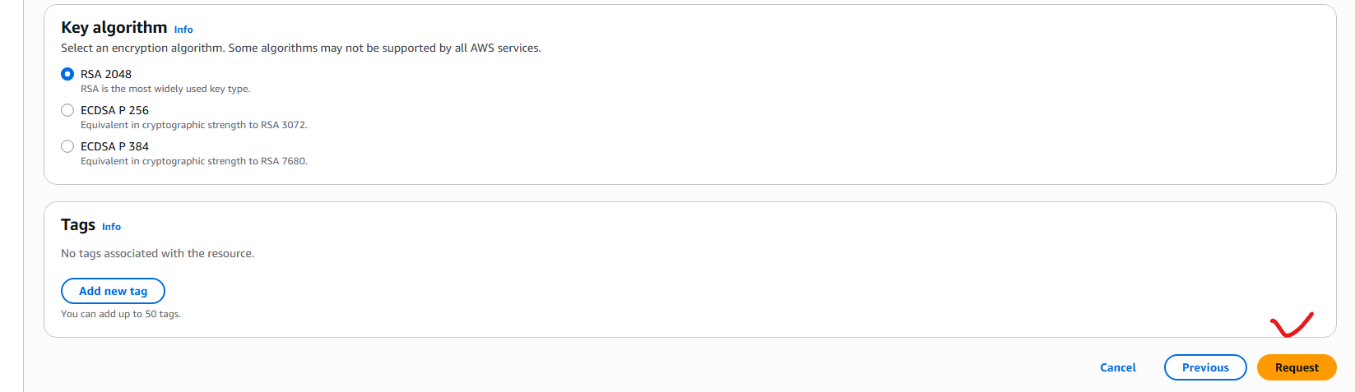

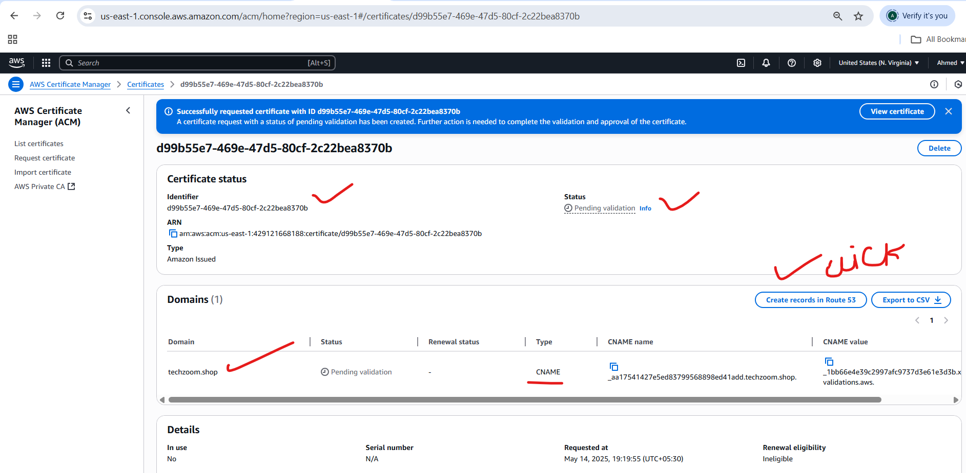

**Note: These are approved when we add this cname in our route53:**

**Cname record is added in to route53.**

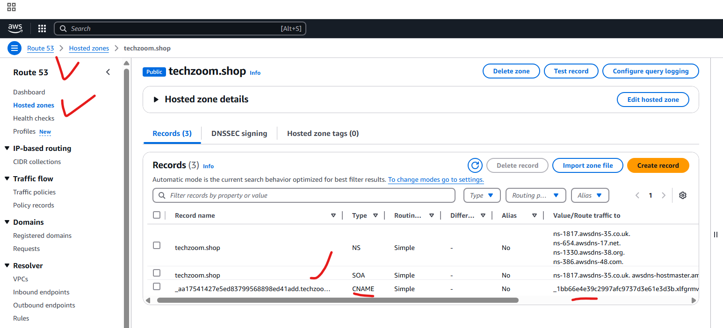

**Now the SSL certificate issued:**

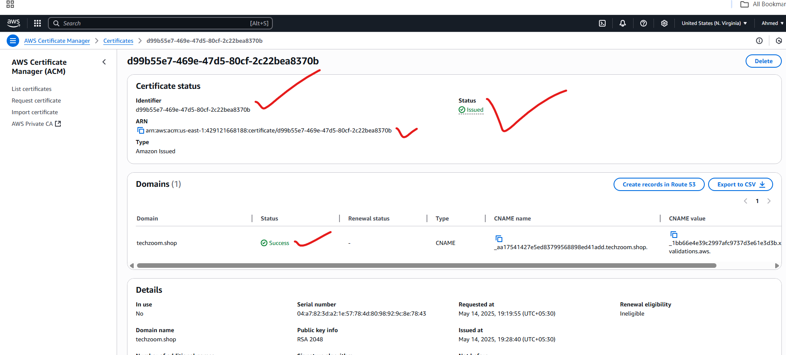

**Now we attached this ssl certificate with cloudfront:**

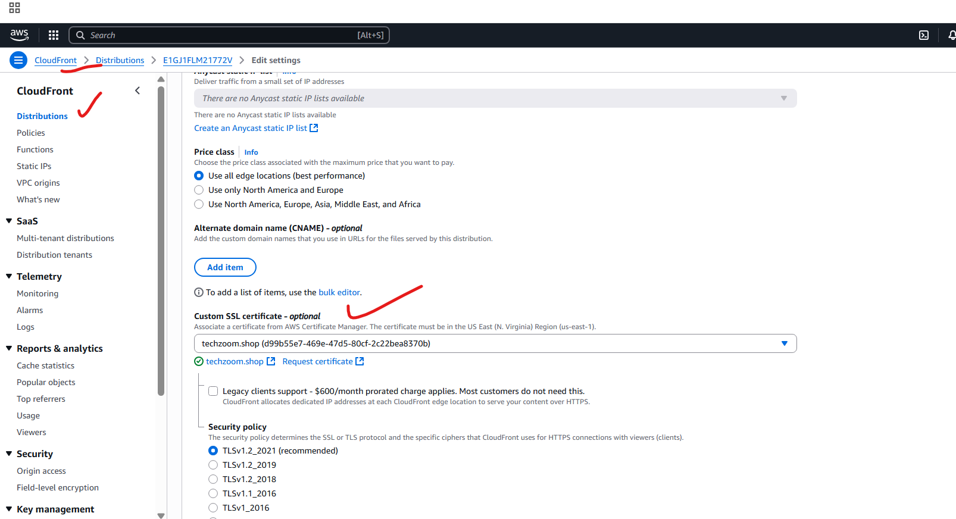

**Compulsory we need to add alternate domain name, otherwise the records does not work.**

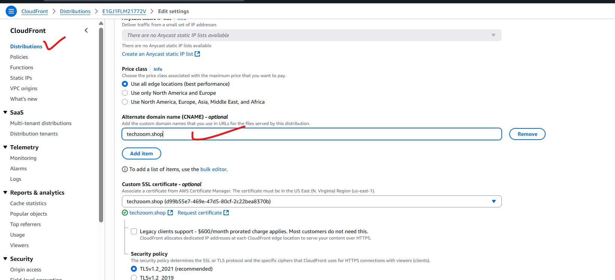

**Successfully updated distribution settings:**

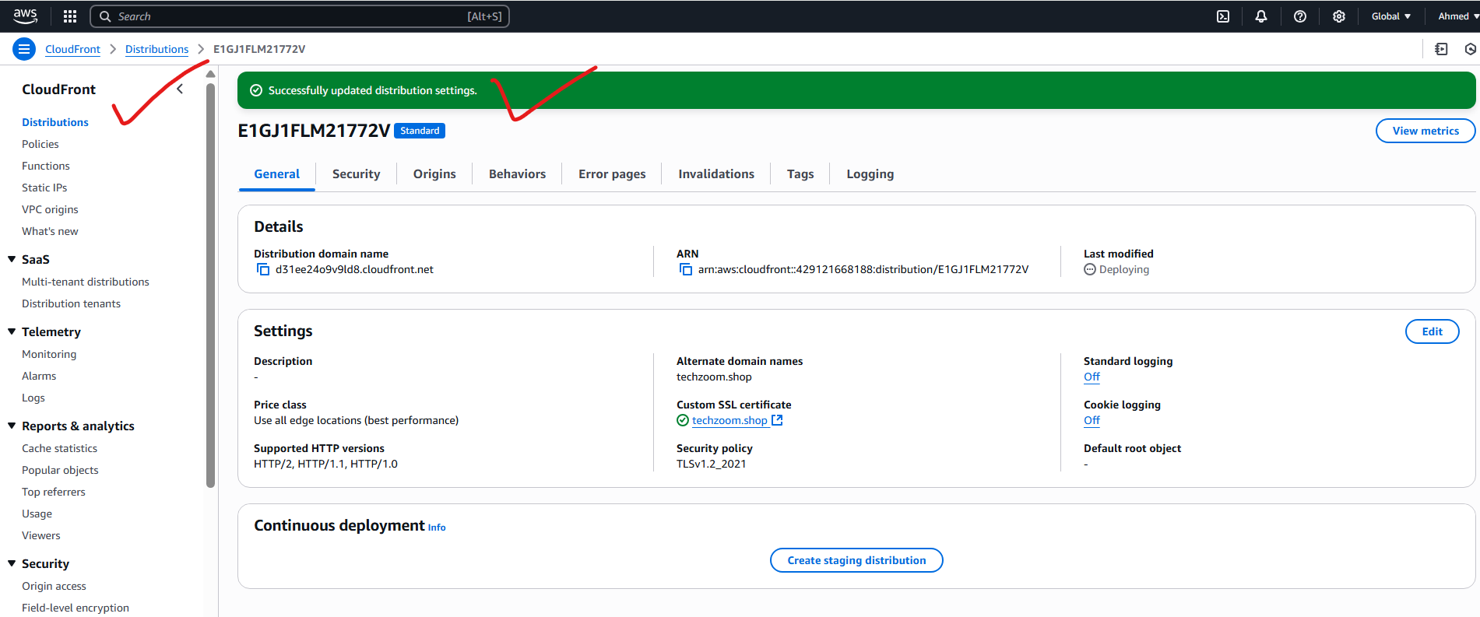

**Goto route53, click on create record, enable “Alias” and then will find distributions automatically in dropdown menu.**

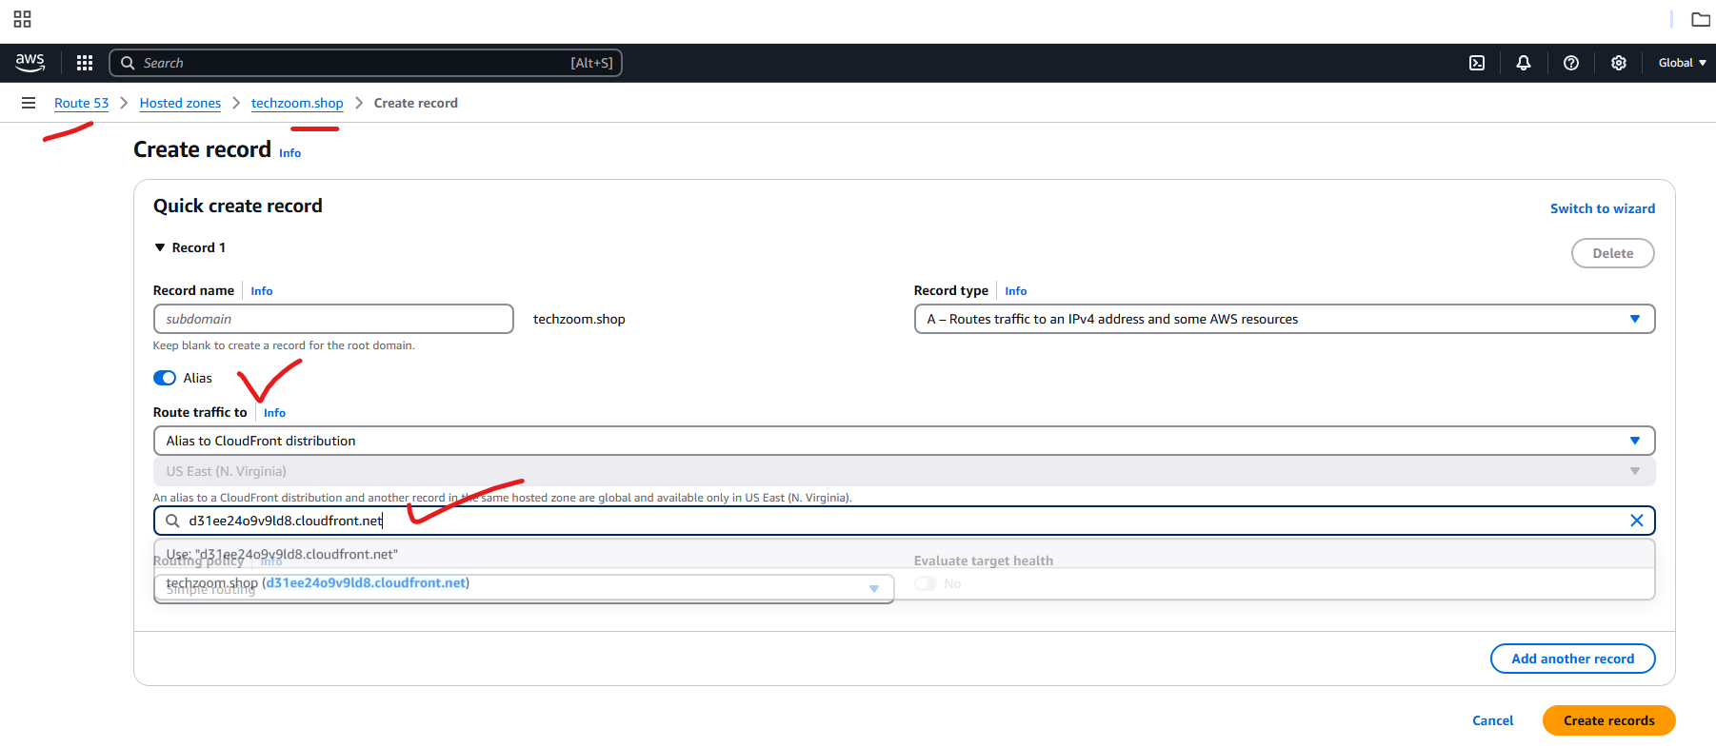

**Record got created:**

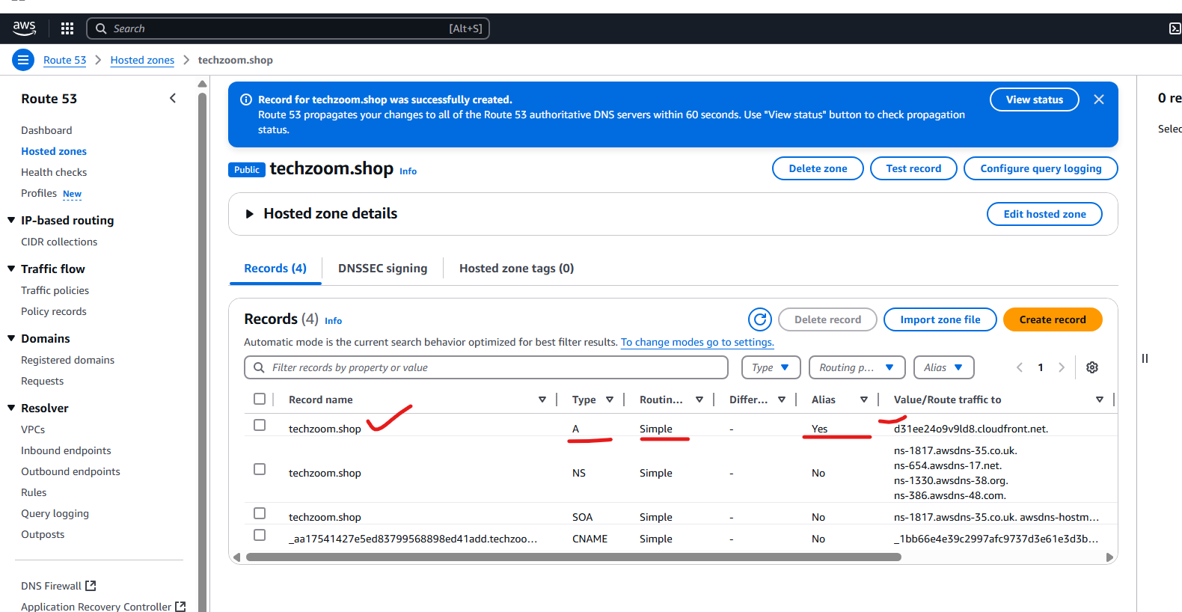

**Redirecting http to https:**

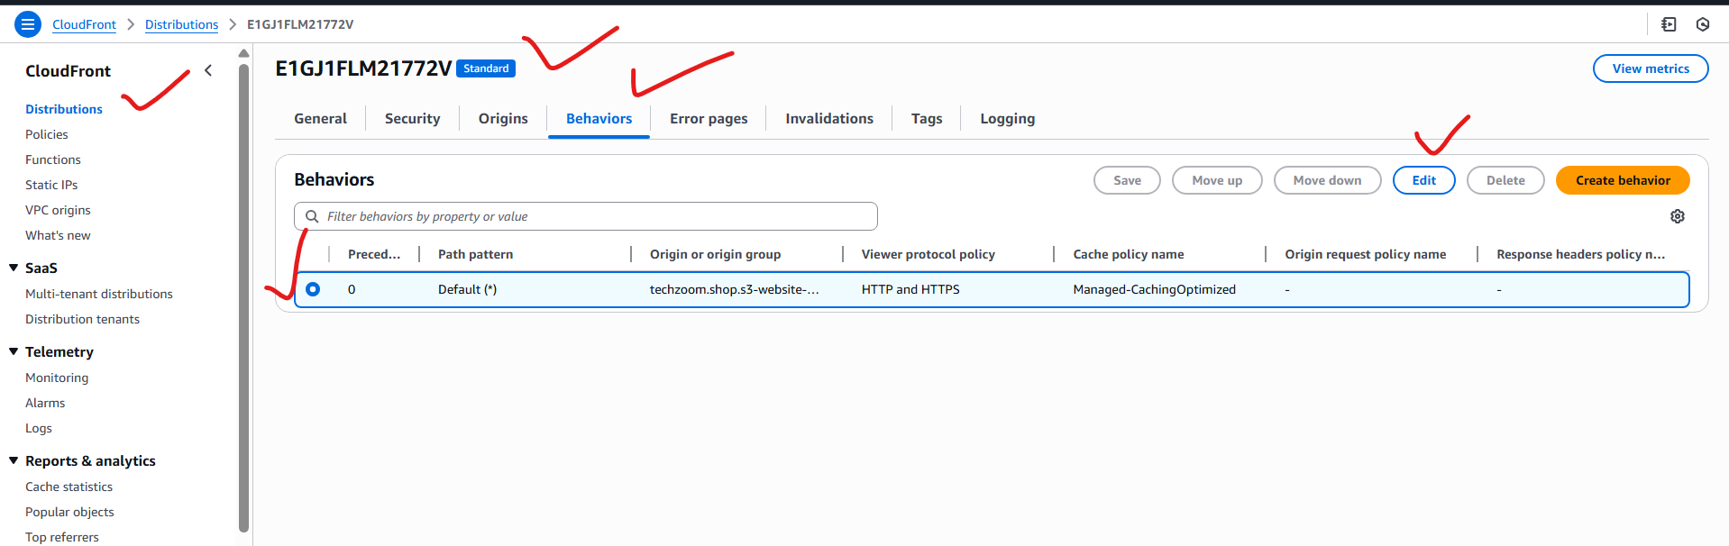

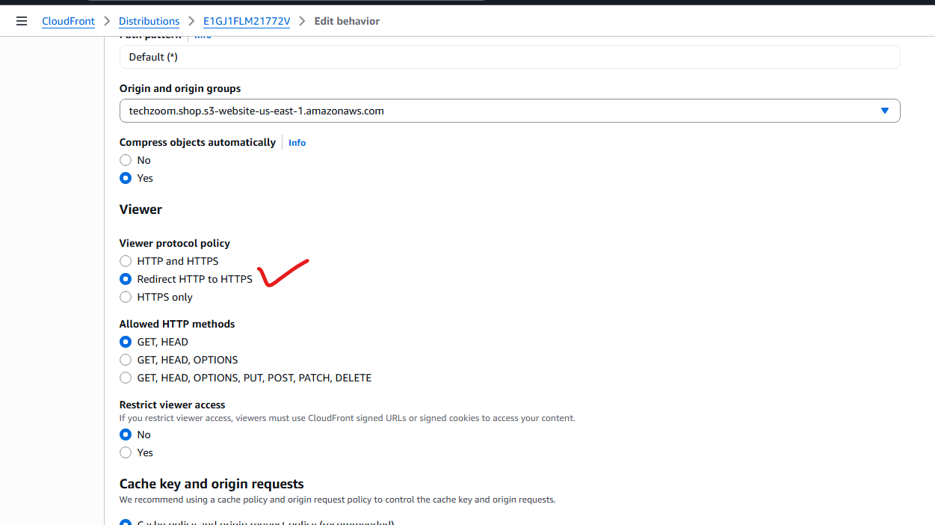

**Geographical location: block our website to the specific geographical locations.**

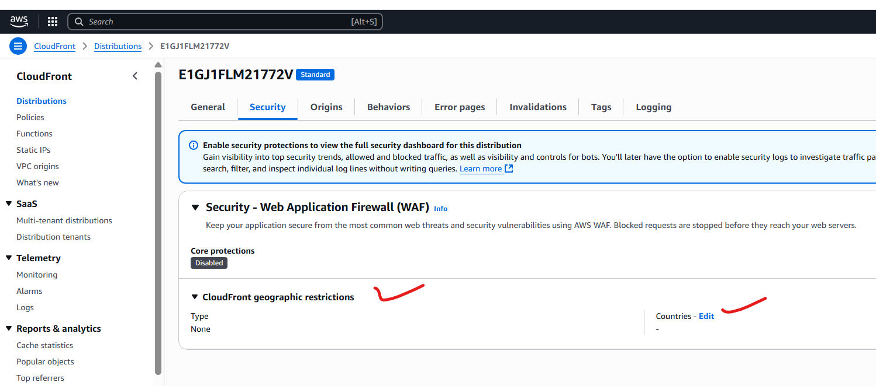

**Select the country which you want to block:**

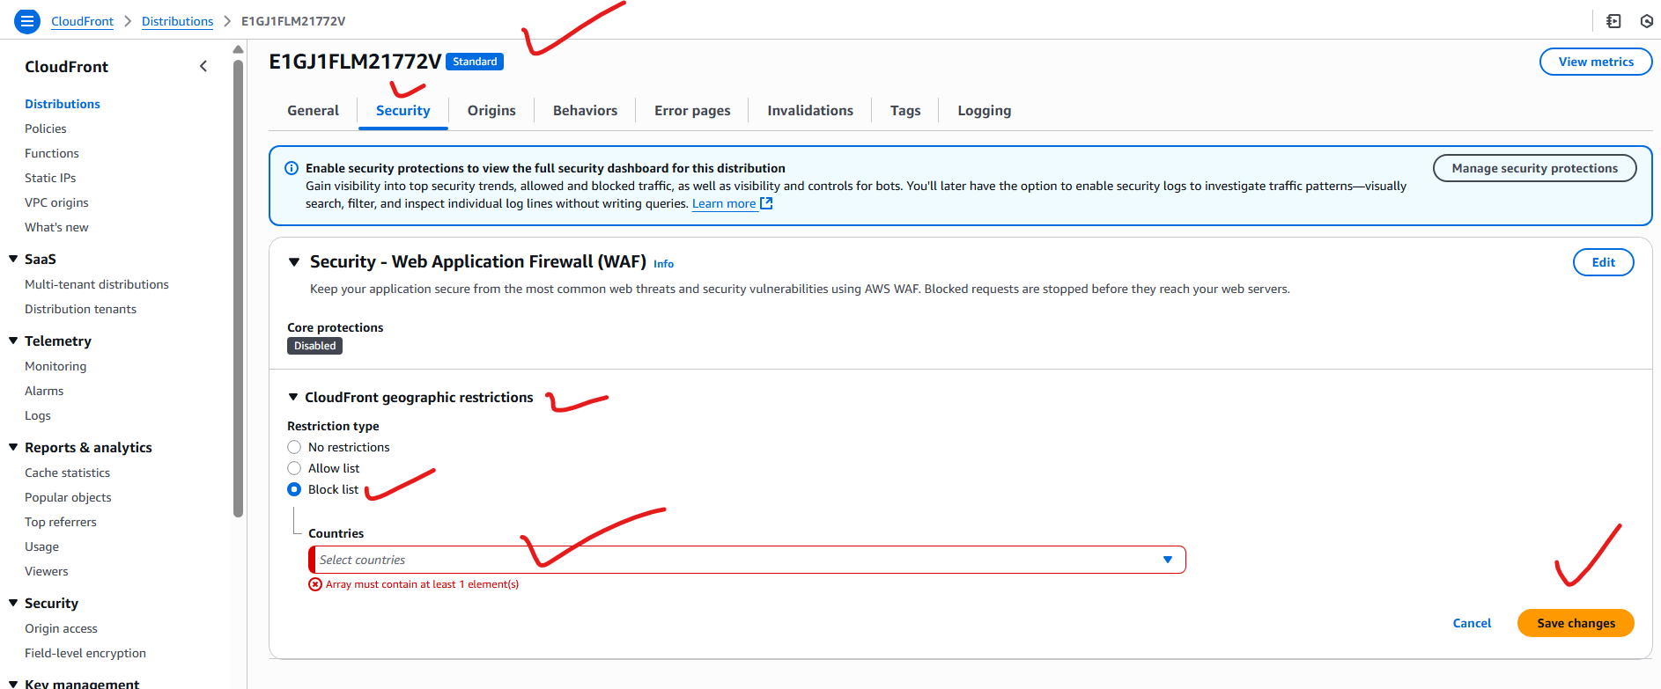

**For example I blocked Canada to not to access my website:**

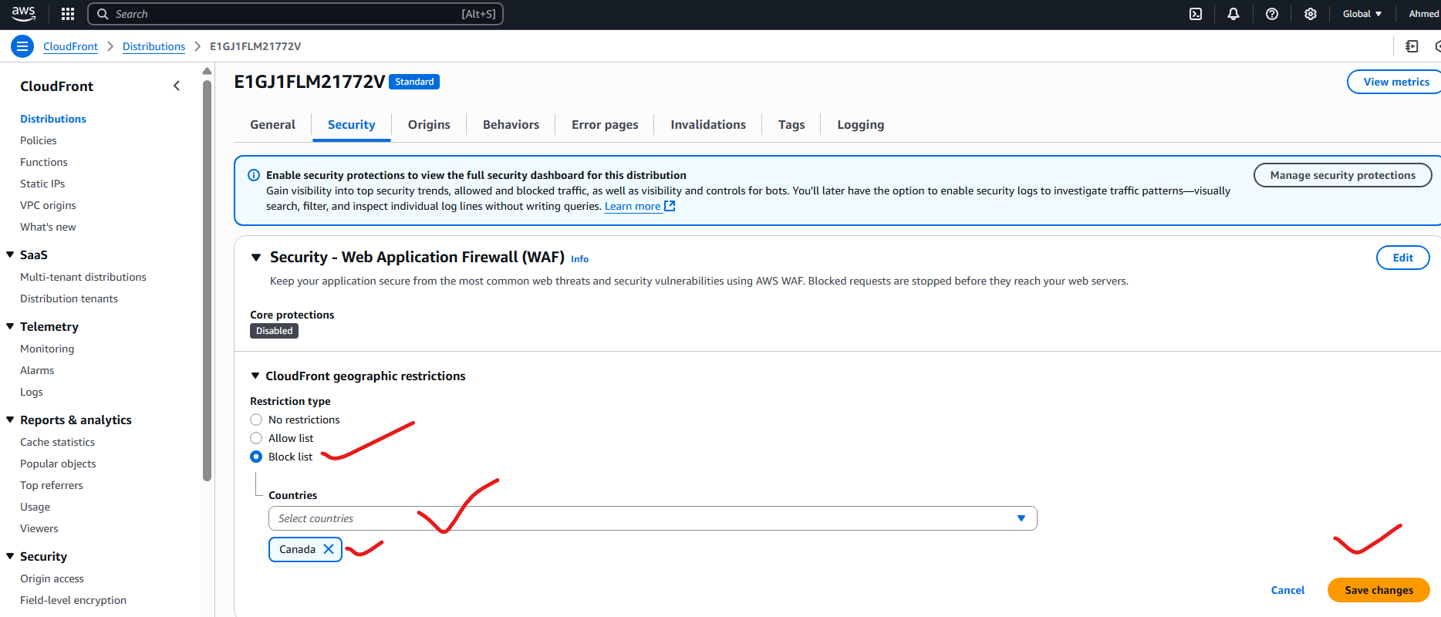

**6) Update the index.html in s3 bucket and the updated file should be accessible by using domain name.**

**Finally successfully created domain name for my website :**

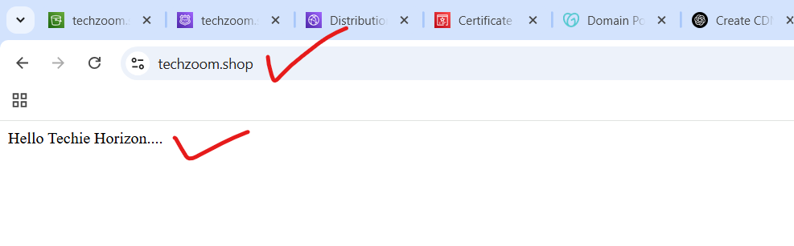

**7) Share the Domain name in slack to test the connetivity.**

**My website domain name is : techzoom.shop**